Interface Sheet

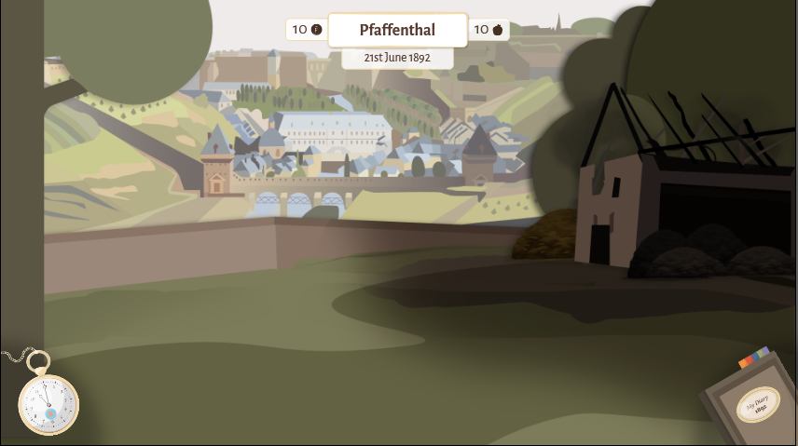

1. Stats
2. Clock
3. Bock

Diary rotation: 13°

Watch rotation: 30°

* Transparenz Black Corner

Assets with Transparence:<https://drive.google.com/drive/folders/1LQFoJjB7XiDRRcvOPCnP3gyBLaY0Yym4>

Stats:

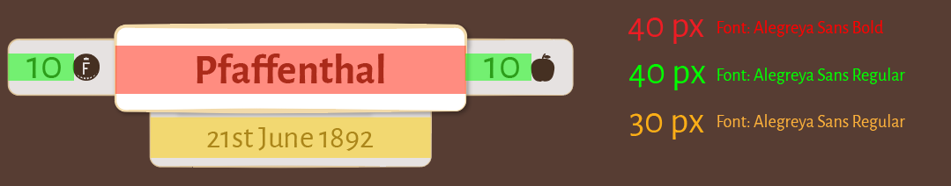

Watch Layers:

